1. ***Change the AWARE Reminder Dialogs to use Historical Events with Forward Health Factors.***

*For Each AWARE Reminder Dialog used at a site among those below:*

***AVEFA FOBT-FIT***

***AVEFA PSA***

***AVEFA ABNORMAL CXR***

***AVEFA ABNORMAL MAMMOGRAM***

1. *For each Reminder Dialog’s* ***“AVEFA XXXX ORDERS GROUP”*** *group element ,* ***“AVEFA XXXX Follow-up Group”*** *group element, and* ***“AVEFA XXXX FOLLOWUP COMMENTS GROUP”*** *group element do the following as required:*

*Change or Add the RESOLUTION* ***TYPE: DONE ELSEWHERE (HISTORICAL)***

**Example:**

For the **“AVEFA FOBT ORDERS GROUP”** group element in the **“AVEFA FOBT-FIT”** Reminder Dialog.

Dialog Edit List Nov 27, 2015@14:09:31 Page: 1 of 3

REMINDER DIALOG NAME: AVEFA FOBT-FIT

-Item Seq.----Dialog Summary---------------------------------------------------

1 1 Group: AVEFA FOBT ORDERS GROUP

2 1.1 Element: AW500 OCC FOBT REPEAT FOBT

3 1.2 Element: AW500 OCC FOBT ORDER CBC WITH DIFF

4 1.3 Element: AW500 OCC FOBT ORDER GI CONSULT

5 1.4 Element: AW500 OCC FOBT ORDER COLONOSCOPY

6 1.5 Element: AW500 OCC FOBT COLRECTAL SURGERY REFERRAL

7 2 Group: AVEFA FOBT FOLLOW-UP GROUP

8 2.1 Element: AW500 OCC DISCUSSED WITH PAT

+---------+ Next Screen - Prev Screen ?? More Actions-------------------->>>

ADD Add Element/Group DS Dialog Summary INQ Inquiry/Print

CO Copy Dialog DO Dialog Overview QU Quit

DD Detailed Display DT Dialog Text

DP Progress Note Text ED Edit/Delete Dialog

Select Item: Next Screen// 1

Select one of the following:

E Edit

C Copy and Replace current element

D Delete element from this dialog

Select Dialog Element Action: E// dit

NAME: AVEFA FOBT ORDERS GROUP Replace

DISABLE:

CLASS: LOCAL//

SPONSOR:

REVIEW DATE:

RESOLUTION TYPE: ?

Enter the resolution status to use when this item is selected.

Answer with REMINDER RESOLUTION STATUS NAME

Choose from:

CONTRAINDICATED

DONE AT ENCOUNTER

DONE ELSEWHERE (HISTORICAL)

LOCAL

ORDERED

OTHER

PATIENT REFUSED

**RESOLUTION TYPE: DONE ELSEWHERE (HISTORICAL) <-enter DONE ELSEWHERE (HISTORICAL**

1. *For all Dialog elements in each Reminder Dialog’s* ***“AVEFA XXX ORDERS GROUP”*** *group do the following as required:*

*And new Item* ***SEQUENCE: xx ITEM: PXRM VISIT DATE FORCED TODAY***

**Example:**

For the **“AW500 OCC FOBT COLRECTAL SURGERY REFERRAL”** dialog element in the **“AVEFA FOBT ORDERS GROUP”** group.

Dialog Edit List Nov 27, 2015@14:13:42 Page: 1 of 3

REMINDER DIALOG NAME: AVEFA FOBT-FIT

-Item Seq.----Dialog Summary---------------------------------------------------

1 1 Group: AVEFA FOBT ORDERS GROUP

2 1.1 Element: AW500 OCC FOBT REPEAT FOBT

3 1.2 Element: AW500 OCC FOBT ORDER CBC WITH DIFF

4 1.3 Element: AW500 OCC FOBT ORDER GI CONSULT

5 1.4 Element: AW500 OCC FOBT ORDER COLONOSCOPY

6 1.5 Element: AW500 OCC FOBT COLRECTAL SURGERY REFERRAL

7 2 Group: AVEFA FOBT FOLLOW-UP GROUP

8 2.1 Element: AW500 OCC DISCUSSED WITH PAT

+---------+ Next Screen - Prev Screen ?? More Actions-------------------->>>

ADD Add Element/Group DS Dialog Summary INQ Inquiry/Print

CO Copy Dialog DO Dialog Overview QU Quit

DD Detailed Display DT Dialog Text

DP Progress Note Text ED Edit/Delete Dialog

Select Item: Next Screen// 6

Select one of the following:

E Edit

C Copy and Replace current element

D Delete element from this dialog

Select Dialog Element Action: E// dit

Dialog Element Type: E// lement

Current dialog element/group name: AW500 OCC FOBT COLRECTAL SURGERY REFERRAL

Used by: AVEFA FOBT ORDERS GROUP (Dialog Group)

NAME: AW500 OCC FOBT COLRECTAL SURGERY REFERRAL Replace

DISABLE:

CLASS: LOCAL//

SPONSOR:

REVIEW DATE:

RESOLUTION TYPE: ORDERED//

ORDERABLE ITEM: VEFA SURGERY//

Finding item: Q VEFA COLRECTAL SURGICAL REFERRAL

FINDING ITEM: VEFA COLRECTAL SURGICAL REFERRAL//

Additional findings:

HF AW500 OCC COLORECTAL SURGERY REFERRAL Finding # 1

Select ADDITIONAL FINDING:

DIALOG/PROGRESS NOTE TEXT:

1>Order Colorectal Surgery Referral

EDIT Option:

ALTERNATE PROGRESS NOTE TEXT:

1>

EXCLUDE FROM PROGRESS NOTE:

SUPPRESS CHECKBOX:

**Select SEQUENCE: 1 🡨Add sequence #**

**ADDITIONAL PROMPT/FORCED VALUE: PXRM VISIT DATE FORCED TODAY forced value LOCAL**

OVERRIDE PROMPT CAPTION:

START NEW LINE:

EXCLUDE FROM PN TEXT:

REQUIRED:

Select SEQUENCE:

REMINDER TERM:

Input your edit comments.

Edit? NO//

1. *For all Dialog element in each Reminder Dialog’s* ***“AVEFA XXXX Follow-up Group”*** *group and for the* ***“AW500 XXXX OTHER FOLLOWUP COMMENTS”*** *Dialog Element in the* ***“AVEFA XXXX FOLLOWUP COMMENTS GROUP”*** *group do the following as required:*

*Change or Add the RESOLUTION* ***TYPE: DONE ELSEWHERE (HISTORICAL)***

*And new Item* ***SEQUENCE: xx ITEM: PXRM VISIT DATE FORCED TODAY***

*This would include elements for “Patient notified and plan of care discussed”, “Follow-up provided by another VA Provider”, “Follow-up visit scheduled”, etc. and also the comments text “AW500 XXXX OTHER FOLLOWUP COMMENTS” Dialog element, etc.*

**Example 1:**

For all Dialog elements in the **“AVEFA CXRY Follow-up Group”** group:

Select REMINDER DIALOG NAME: **AW500 CXRY PAT OPTED NO TREAT** dialog element

LOCAL

...OK

NAME: AW500 CXRY PAT OPTED NO TREAT TYPE: dialog element

**RESOLUTION TYPE: DONE ELSEWHERE (HISTORICAL)** 🡨enter

ADDITIONAL FINDINGS: AW500 CXRY PAT OPTED NO TREATMENT

**SEQUENCE: 1** 🡨 add new sequence # **ITEM: PXRM VISIT DATE FORCED TODAY** 🡨enter item

DIALOG/PROGRESS NOTE TEXT: Patient has opted not to treat

CLASS: LOCAL

EDIT DATE: OCT 04, 2014@00:49:43 EDIT BY: CLINCOORDINATOR,TWO

EDIT COMMENTS: Exchange Install

**Example 2:**

For an **“AW500 CXRY OTHER FOLLOWUP COMMENTS”** Dialog Element in the **“AVEFA CXRY FOLLOWUP COMMENTS GROUP”** group:

Select REMINDER DIALOG NAME: **AW500 CXRY OTHER FOLLOW-UP COMMENTS** dialog el

ement LOCAL

NAME: AW500 CXRY OTHER FOLLOW-UP COMMENTS

TYPE: dialog element EXCLUDE FROM PROGRESS NOTE: NO

**RESOLUTION TYPE: DONE ELSEWHERE (HISTORICAL)** 🡨enter

ADDITIONAL FINDINGS: AW500 CXRY OTHER FOLLOW-UP COMMENTS

SEQUENCE: 1 ITEM: PXRM COMMENT

OVERRIDE PROMPT CAPTION: Comments: START NEW LINE: YES

**SEQUENCE: 2** 🡨 add new sequence # **ITEM: PXRM VISIT DATE FORCED TODAY** *<-enter item*

DIALOG/PROGRESS NOTE TEXT:

CLASS: LOCAL

EDIT DATE: OCT 04, 2014@00:49:43 EDIT BY: CLINCOORDINATOR,TWO

EDIT COMMENTS: Exchange Install

1. *Add an additional Reminder Dialog Element at the end of the* ***“AVEFA XXXX Follow-up Group”*** group as an additional finding to count for follow-up with notation ***“*AW500 XXX ENTERED NOTE”** *acting as a follow-up as well as a follow-up tracking element*

*First create a specific new health factor for this new Reminder Dialog Element for the particular Reminder Dialog. This unique Health Factor name should be named with notation* ***“AW500 XXX ENTERED NOTE” (****i.e. for a* ***FOBT Reminder Dialog*** *this would be* ***“AW500 OCC ENTERED NOTE****”)*

*Then add a new Dialog element with notation* ***AW500 XXX ENTERED NOTE*** *with a new and next sequence # at the end of the* ***“AVEFA XXXX Follow-up Group”*** *Group element****.***

**Example:**

**“AW500 OCC ENTERED NOTE”** for the FOBT Reminder Dialog **“AVEFA FOBT-FIT”**

REMINDER DIALOG NAME: AVEFA FOBT-FIT

Group: AVEFA FOBT FOLLOW-UP GROUP

+Item Seq. Dialog Summary

9 2.2 Element: AW500 OCC REFER TO ANOTHER VA PROV

10 2.3 Element: AW500 OCC FOLLOWUP

11 2.4 Element: AW500 OCC LIMITED LIFE

12 2.5 Element: AW500 OCC PAT NO LONGER IN CARE

13 2.6 Element: AW500 OCC PAT OPTED NO TREAT

**14 2.7 Element: AW500 OCC ENTERED NOTE** 🡨-Add new Dialog element

15 3 Group: AVEFA FOBT FOLLOWUP COMMENTS GROUP

+ + Next Screen - Prev Screen ?? More Actions >>>

ADD Add Element/Group DS Dialog Summary INQ Inquiry/Print

CO Copy Dialog DO Dialog Overview QU Quit

DD Detailed Display DT Dialog Text

DP Progress Note Text ED Edit/Delete Dialog

Select Item: Next Screen//**ADD**

Enter a new SEQUENCE NUMBER: **2.7**

Add sequence 7 to group AW500 OCC FOLLOW-UP GROUP: N//**y**

Select new DIALOG ELEMENT: **AW500 OCC ENTERED NOTE**

Are you adding 'AW500 OCC ENTERED NOTE' as

a new REMINDER DIALOG? No// **Y**

Dialog Element Type: E// lement

Current dialog element/group name: **AW500 OCC ENTERED NOTE**

Used by: AVEFA FOBT FOLLOW-UP GROUP (Dialog Group)

NAME: **AW500 OCC ENTERED Note** Replace

CLASS: **LOCAL**//

SPONSOR:

REVIEW DATE:

**RESOLUTION TYPE: DONE ELSEWHERE (HISTORICAL)** <- enter

ORDERABLE ITEM:

FINDING ITEM:

Additional findings:

**HF AW500 OCC ENTERED NOTE Finding # 1** 🡨-enter new HF finding

Select ADDITIONAL FINDING:

DIALOG/PROGRESS NOTE TEXT:

**1>FOBT Note Entered** *🡨Enter appropriate text (i.e. “FOBT Note Entered” , “Chest X-Ray Note Entered”, etc.) appropriate for the type of Reminder Dialog*

EDIT Option:

Edit line:

EDIT Option:

ALTERNATE PROGRESS NOTE TEXT:

1>

EXCLUDE FROM PROGRESS NOTE:

SUPPRESS CHECKBOX: **SUPPRESS//** *🡨as suppressed Dialog element*

**Select SEQUENCE: 1//** 🡨 add new Item sequence #

**SEQUENCE: 1//**

**ADDITIONAL PROMPT/FORCED VALUE: PXRM VISIT DATE FORCED TODAY** 🡨enter

OVERRIDE PROMPT CAPTION:

START NEW LINE:

EXCLUDE FROM PN TEXT:

REQUIRED:

Reminder Term:

The Dialog Element is shown below as suppressed “FOBT Note Entered”. No actual selection from AWARE Reminder Dialog is needed to create a Forward Health Factor “**AW500 OCC ENTERED NOTE” in a** Historical Event visitwith **“Finish”** button entry**.**

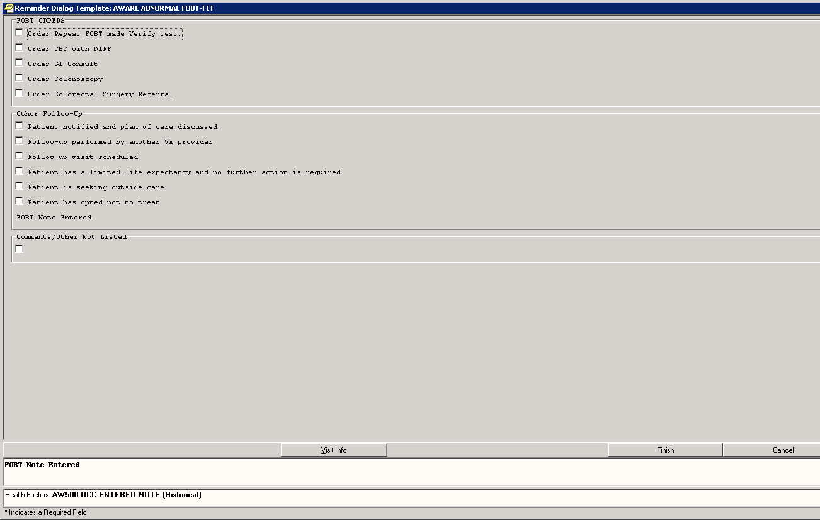

1. ***The modified AWARE Reminder Dialogs can be used for Progress Note entry for ADDENDUMS to existing (old) visits or within a General Telephone Note to generate a Historical Event with Forward Health Factor(s).***

See example addendum below with an invoked “Shared Templates” drawer, “AWARE ABNORMAL FOBT-FIT” Reminder Dialog Template to a previous visit. In the simple case of no selections at all, it still generates an “AW500 OCC ENTERED NOTE” Historical (forward) HF, and with some additional entered comment text an “AW500 OCC OTHER FOLLOW-UP” Historical (forward) HF is made.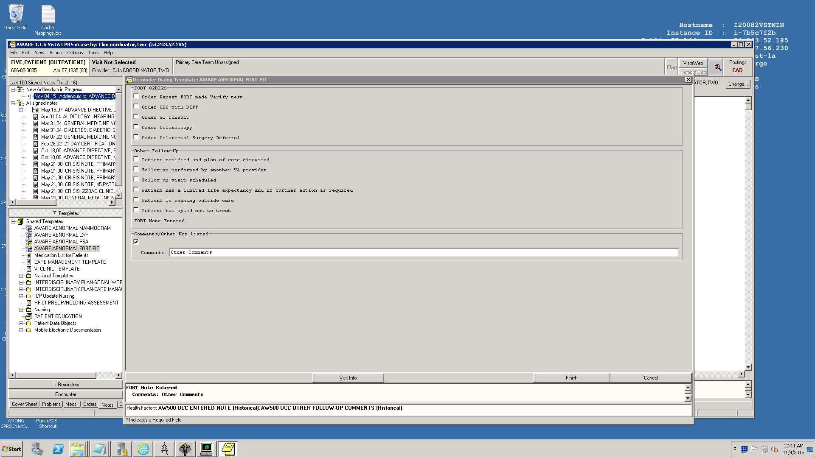

Also an Addendum or a General Telephone Note could have “free text” entered first in the Progress Note and then with a subsequent invoked “Shared Templates” drawer, and an AWARE Reminder Dialog, i.e. the “AWARE ABNORMAL FOBT-FIT” Reminder Dialog Template can be entered to record follow-up actions. An Historical Event can be made with Forward Health factors for (a) each Orders Follow-up entry box checked, (b) each Other Follow-up entry box checked, (c) the Comments/Other Not Listed box checked, or (d) just the unchecked FOBT Note entry by default. See below:

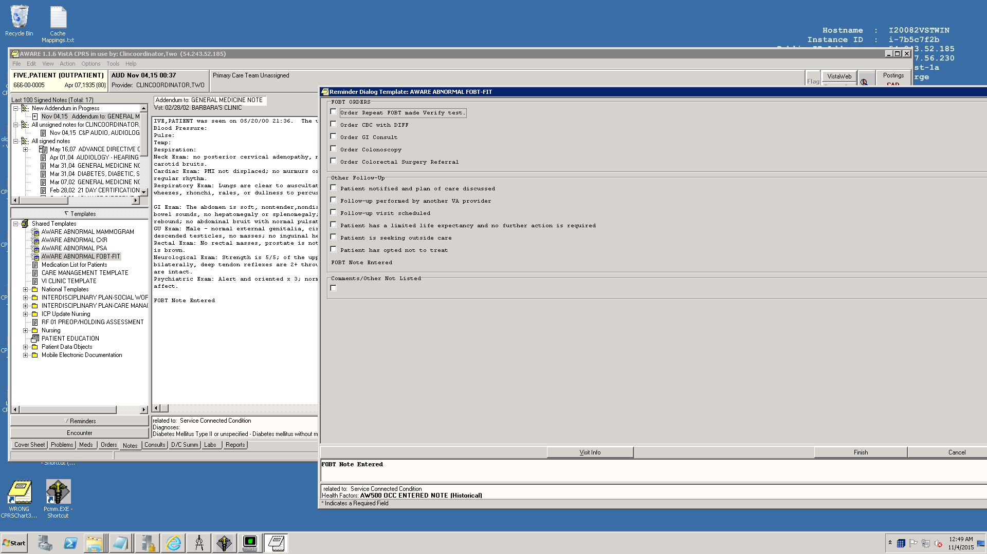

**Example Forward Health Factor Details:**

Select V HEALTH FACTORS: **AW500 OCC ENTERED NOTE**

8 AW500 OCC ENTERED NOTE FIVE,PATIENT NOV 3,2015

CHOOSE 1-8: 8 AW500 OCC ENTERED NOTE FIVE,PATIENT NOV 3,2015

HEALTH FACTOR: AW500 OCC ENTERED NOTE PATIENT NAME: FIVE,PATIENT

VISIT: **NOV 03, 2015** AUDIT TRAIL: 19-A 10000000087;

PACKAGE: ORDER ENTRY/RESULTS REPORTING

DATA SOURCE: TEXT INTEGRATION UTILITIES

OUTPUT FROM WHAT FILE: VISIT

Select VISIT: **NOV 03,2015** NOV 03, 2015 FIVE,PATIENT 1B74-ALN

VISIT/ADMIT DATE&TIME: **NOV 03, 2015**

DATE VISIT CREATED: NOV 03, 2015@10:48:41

TYPE: VA PATIENT NAME: FIVE,PATIENT

SERVICE CATEGORY: **EVENT (HISTORICAL)** DEPENDENT ENTRY COUNT: 1

PARENT VISIT LINK: **MAY 16, 2007@09:05 🡨-addendum made to this visit with AVEFA FOBT-FIT Reminder Dialog**

DATE LAST MODIFIED: NOV 03, 2015@10:48:42

CREATED BY USER: CLINCOORDINATOR,TWO OPTION USED TO CREATE: OR CPRS GUI CHART

VISIT ID: 1B74-ALN PATIENT STATUS IN/OUT: OUT

ENCOUNTER TYPE: PRIMARY SERVICE CONNECTION EDIT FLAG: EDITABLE

AGENT ORANGE EDIT FLAG: EDITABLE IONIZING RADIATION EDIT FLAG: EDITABLE

SW ASIA CONDITIONS EDIT FLAG: EDITABLE

MST EDIT FLAG: EDITABLE HEAD AND NECK CANCER EDIT FLAG: EDITABLE

COMBAT VETERAN EDIT FLAG: EDITABLE PROJ 112/SHAD EDIT FLAG: EDITABLE

PACKAGE: PCE PATIENT CARE ENCOUNTER DATA SOURCE: TEXT INTEGRATION UTILITIES